**Kumar Gaurav 20122065**

**Lab – 1, AWS EC2**

1. **Describe IaaS**

IaaS is one of the main cloud computing models. IaaS – Infrastructure as a service. It offers pay-as-you-go infrastructure for a company. That is the most basic form of cloud computing.

With IaaS, a client rents a variety of infrastructure components such as data centres, servers, cloud storage, and networking solutions from a provider. Basically, IaaS offers access versus ownership. An IaaS provider takes responsibility for the infrastructure, whereas users are in charge of installing, managing, maintaining, and supporting their apps and operating systems.

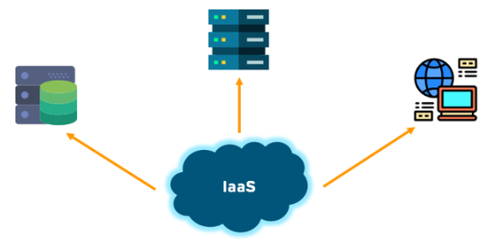

**Few of the key features of IaaS are as follows**:

Resources are highly scalable

Cost depends on the consumption

A single piece of hardware serves many users

The client has complete control over the architecture

**The Pros of using IaaS are**:

The most flexible and dynamic model

Cost-effective, pay for what you use

Easy to use since it deploys hardware automatically

**The Cons of Using IaaS are:**

Data security is an issue due to multitenant architecture

Team training is required to learn about the new infrastructure

When server crashers at the vendor side, customers cannot access their data for a while

1. **List of computer services in AWS**

* Amazon EC2
* Amazon EC2 Auto Scaling
* Amazon EC2 Image Builder
* Amazon Lightsail
* AWS App Runner
* AWS Batch
* AWS Elastic Beanstalk
* AWS Fargate
* AWS Lambda
* AWS Serverless Application Repository
* AWS Outposts
* AWS Wavelength
* VMware Cloud on AWS

1. **AWS EC2 Instance and install the necessary packages**

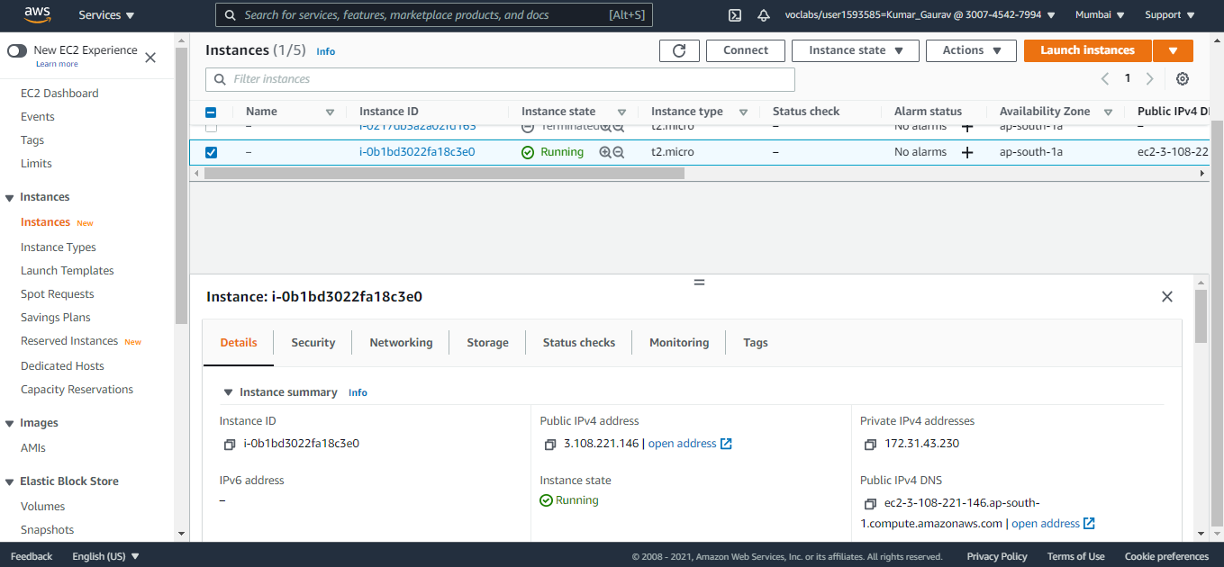

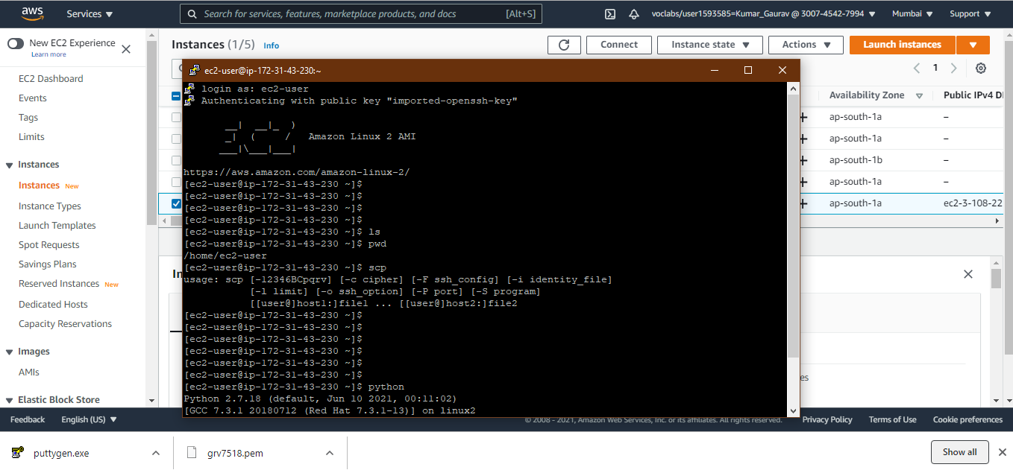

**sudo yum groupinstall "Development Tools"**

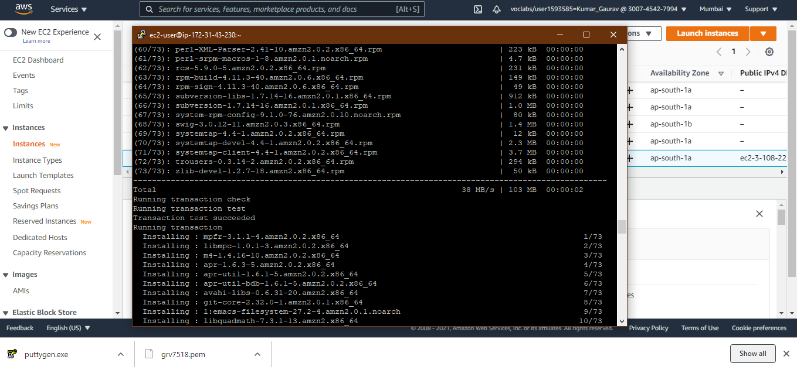

**Python run**

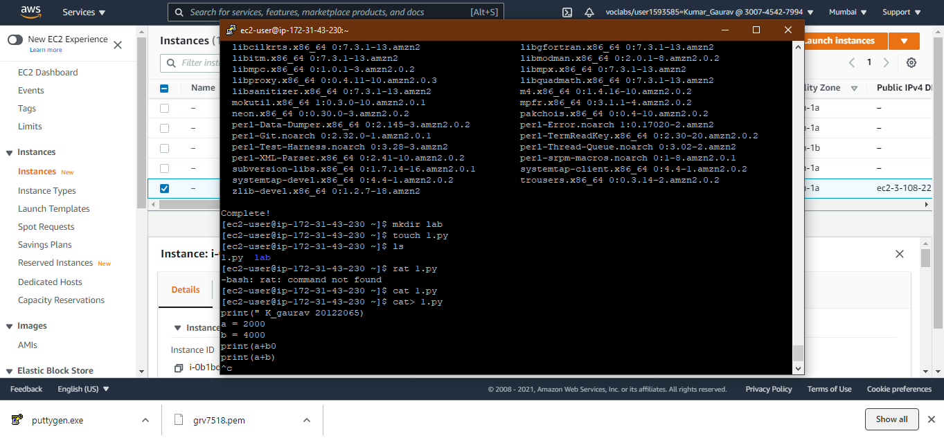

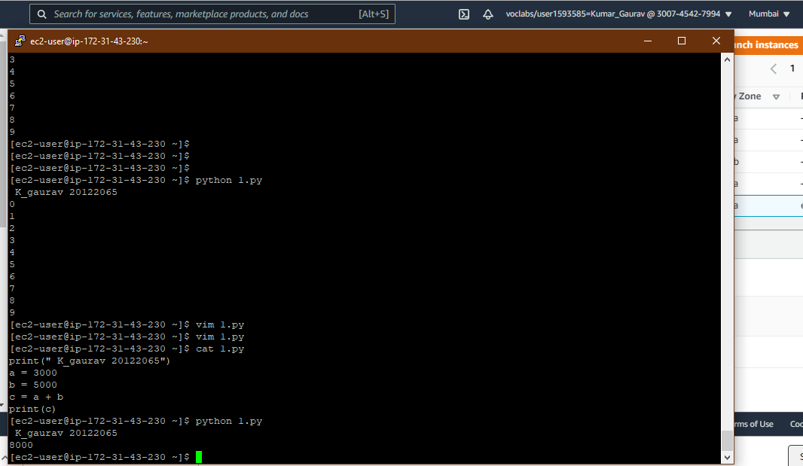

**Python is working successfully! Done**